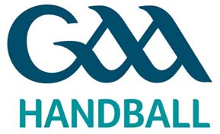

GAA Handball Official request for hosting a Tournament 2013

Name of Club/County: _____________________________________

Name of Tournament: _____________________________________

Tournament Info: _____________________________________

Date(s) to be hosted: _____________________________________

Submitted by: _____________________________________

Club Official Details: _____________________________________

_____________________________________

Contact Info: E:___________________________________

T:___________________________________

Signed by: _____________________________________

If there is a Specific Request for this Tournament (where Mens and Ladies Open Singles events are included) to be an Official Ranking Tournament then the additional form must also be completed to accompany this form.

Club Tournaments/Events will not be shown on the Official National Clár of GAA Handball Ireland but will be presented in full under the ‘TOURNAMENTS’ Tab of the National Website where an application has been submitted. This will also be available for Clubs to use to promote their tournaments, including entry forms, posters, etc…

Only Clubs and Players registered with GAA Handball Ireland are eligible to compete and the appropriate sanction obtained (see below) in order for Insurance to be substantiated for the club/players involved.

Original form to be sent to: John Kelly, National Administrator, Liathróid Láimhe CLG na hÉireann, Páirc an Chrócaigh, Baile Átha Cliath 3 or Email: info.handball@gaa.ie
Copy must by sent to: Provincial Council Secretary & County Committee Secretary

Fó Rialacha 2012: PERMITS FOR TOURNAMENTS
45. All friendly matches and tournaments arranged by Clubs within counties must have the sanction of the County Committee.
46. All inter-county tournaments, challenge matches, etc. must have the recommendation of the County Committee concerned and the sanction of the Provincial or Central Council.

