Co. Wexford Juvenile 60x30 Irish Nationals Report
The 60x30 Irish Nationals Handball Championship was held recently in venues the length and breathe of the county, with all big alley courts hosting games during the course of the weekend. The juvenile format at the Nationals is doubles only and Wexford had a total of 12 pairings going into the battle against the very best boys and girls from across the country.
Representing Wexford in the Girls 13&Under taking place in Taghmon were the St. Josephs pairing of Jodie Keeling and Ellie Murphy O’Gorman. With Jodie only been 11 years old the girls faced a task from the start, but on the handball scene both girls are known for their amazing talent and nothing seems to faze these girls. The girls got off to a great start winning their first game 15-1:15-6 against the pairing from Kilkenny. Up next for the girls were a strong Clare pairing of Chloe Philpot & Ellie Casey, this game was by far the game of the day in this age group. The Wexford girls got off to a slow start losing the first 15-7, but stepped up to win the second 15-9, heading into the third both Wexford girls looked tired and the Clare girls took a strong lead that was just too much to pull back although Jodie and Ellie put up a fight they lost the third 11-2. Both Wexford girls will have to convert back to singles mode now as they will face each other in the upcoming Under 13 County Singles final.
Flying the county colours at Girls 17&Under were Eva Crean (St. Josephs) and Cliodhna O’Connell (Coolgreany) these girls are certainly no strangers to stepping out on the big stage and are a pairing other county’s wanted to avoid. Facing the girls first in their semi-final game was a pairing from Kilkenny R O’Keeffe & D O’Keeffe, the girls didn’t get going at all in the first game losing 15-4. Knowing they had to step up or be out the girls upped their game taking the next game 15-9. Kilkenny weren’t finished just yet and a battle ensued in the third which produced some cracking handball but thankfully the Wexford girls clinched it 11-9. Moving on the final the Wexford girls came up against the top seeded pairing from Kildare the power hitter Leah Doyle and Abbey Tarrant. Knowing that losing the first game was not option the Wexford girls showed tremendous spirit to take the first by the narrowest score of 15-14. The Kildare girls showed the large crowd why they are the best around taking the second by 15 to 10. The Kildare girls kept the pace up in the third and our girls matched them shot for shot but unfortunately Kildare won the championship by 11 to 6.
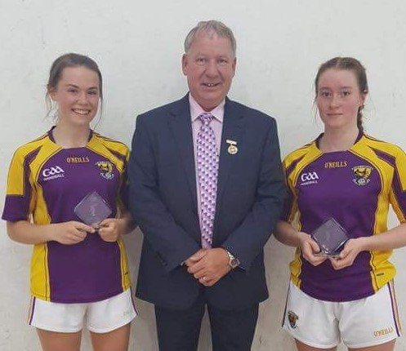
Girls Under 17 Runners Up with GAA Handball President Joe Masterson
Up in Coolgreany saw the coming together of the cream of the crop in the Boys 13&Under, Boys 15&Under and the Boys 17&Under. In the Boys 13&Under Wexford had two pairings taking part in the form of Conor Horan & John Connors both local boys and brothers duo Rory Gilbert and Conor Dobbs from St. Josephs. The St.Josephs brothers wouldn’t get too many chances to play doubles competitively with each other, Rory aged only 11 decided to move up ages and a different ball to compete in the Nationals with his brother Conor. Receiving a bye in the first round, the brothers had to face top seeds and All Ireland winners Conor Holden and Kyle Jordan (Kilkenny), this proved to be a step too far and went down in two games to zero. The Wexford brothers then had a chance over in the plate final but unfortunately faced another strong pairing from Kilkenny and also lost out by 21 to 9 score line.
The other Wexford pairing from Coolgreany Conor and John started off their campaign against Kilkenny. The boys didn’t get off to a great start losing the first game 15-9, but with the support of the home crowd the boys dug deep to take the second 15-12. In the third both pairings matched each other score for score neither giving anything away, but as the score stuck on 7 a piece the Wexford lads made sure to make their two hands count when serving and ended up taking the game 11-7. In the second match the Coolgreany boys faced Galway pairing of Glynn & Kelly who proved too strong for the Wexford duo, the Wexford chaps can take consolation in being defeated by this pair as the Galway boys ended up the overall winners of this age group and John is still only aged 11.

In the boys 15&Under Wexford had three doubles pairings, seeded players Mark Doyle (Taghmon) and St. Josephs player Josh Kavanagh, one pairing from Castlebridge David Doyle and Joe Devereux and Dean O’Neill (Ballymitty) and Diarmuid Moore (St. Josephs) completing the trio. The Castlebridge pairing faced a daunting start when they came up against hot favourites Kilkenny pairing Kyle Dunne and Billy O’Neill. The boys found it hard to get any sort of rhythm going and the Kilkenny lads took this one in two straight games. The Wexford pairing of Dean and Diarmuid came up against a double pairing from Mayo and got off to a flyer taking the first game. They had a slight lead in the second and seemed to be completely in control when their concertation seemed to just drop and the boys lost. Moving into the third they found a bit of their first game form but had left it too late losing the third 11-7. This set up an all Wexford Plate final which went the way of Dean and Diarmuid on a 21-6 score but this does not reflect the game that was played the Castlebridge boys just lacked a bit of power and experience to match the big hitters of Dean and Diarmuid. Well done to Dean and Diarmuid great stuff.
With seeded players Mark and Josh receiving a bye in the first round, they faced the hard task of Kilkenny duo Sean Barron and Billy Drennan at the semi-final stage but came through this game fair easy taking it two games to zero. Up next for the amazingly talented Wexford lads were the equally talented boys Kyle Dunne and Billy O’Neill from Kilkenny. The Wexford lads showed the Kilkenny boys how to play handball in the first game winning 15-10, but the Kilkenny lads turned the tables in the second taking it 15-4. Entering the court at the start of the third this thrilling final could go either way, all four players are fantastic young players, all having won National titles before no one could dare call this. It was nail biting handball and Kilkenny produced some excellent shots pinning the Wexford lads back once they took a slight lead, they never let it go taking this prestigious title back to Kilkenny on a 11-7 score line, hard luck to Mark and Josh.

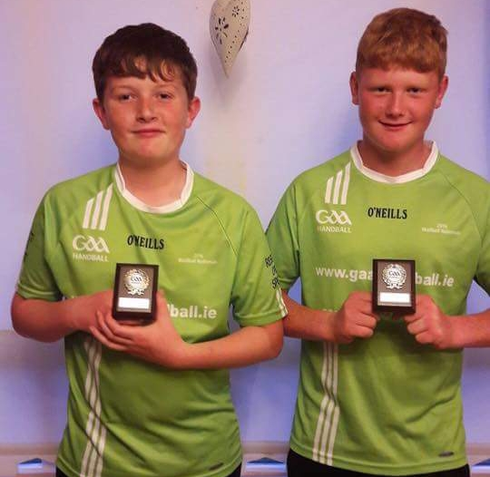
Boys Under 15 Plate Final Winners

The Boys 17&Under saw two pairings from Wexford entering the Nationals. Adam Walsh and Cian Kehoe (St. Josephs) and Colm Parnell (Ballyhogue) joining forces with Ciaran Power (Coolgreany). Both U17 pairings started their campaign off against players from Kilkenny. Kilkenny were hot favourites to take this title before the start of the day and they certainly didn’t disappoint. Adam and Cian faced top seeded players Jack Doyle and Eoin Brennan in their semi-final game and although they put it up to them they couldn’t just match them on killer shots. It was much the same with Colm and Ciaran who played some great handball but lost out to Conor Cooney and Conor Drennan. This set up another all Wexford Plate Final and this also provided the crowd with what was the game of the day. All four Wexford players produced outstanding, excellent handball and both sets of boys were determined to win this one. Neither pair took any great lead it was point for point all the way and at 19 all Adam and Cian took their chance with serve and gained the remaining two aces to take them over the finish line. Great handball from four amazing players who are improving at every stage.
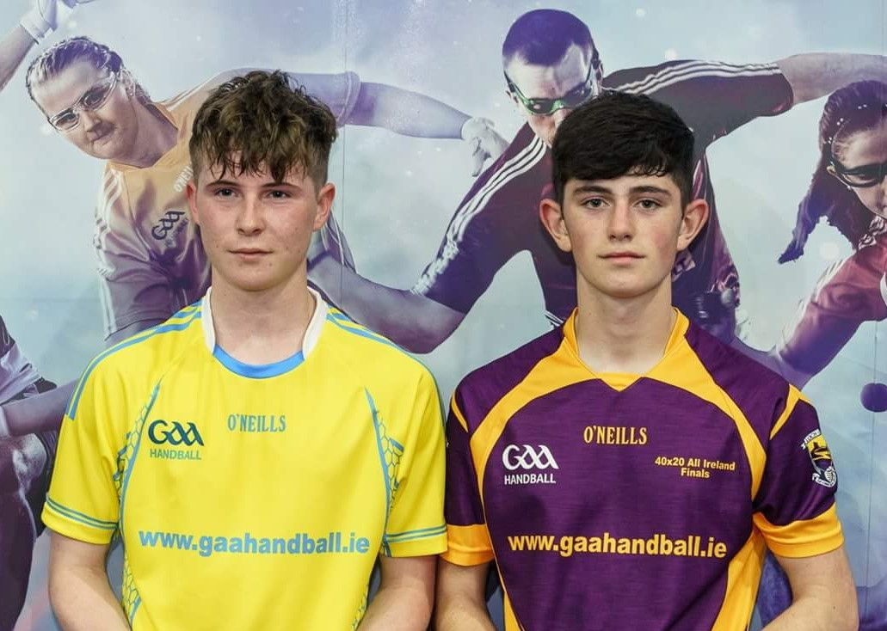
Boys Under 17 Winners

Down in Castlebridge the Boys11&Under fun style blitz was held with Wexford having three pairings taking centre stage. Castlebridge Duo of Joshua Roche and Killian Buckley, St. Marys Duo Jamie Barnes and Jack Creane and Castlebridge player Lucas Kehoe teaming up with Carlow player Andy Smyllens. The format for this blitz is every double’s pairing plays each other once with no winner be declared at the end. The boys had five games in total with pairings from Tipperary, Kilkenny and Meath joining them for this fun filled day. At the end of the day they were all presented with a GAA Handball gift bag by Senior Women’s Runner Up Martina McMahon from Limerick which went down a treat. The level of handball that was on display by these young handballers was immense and the future is bright with these boys around, well done boys and keep it going.
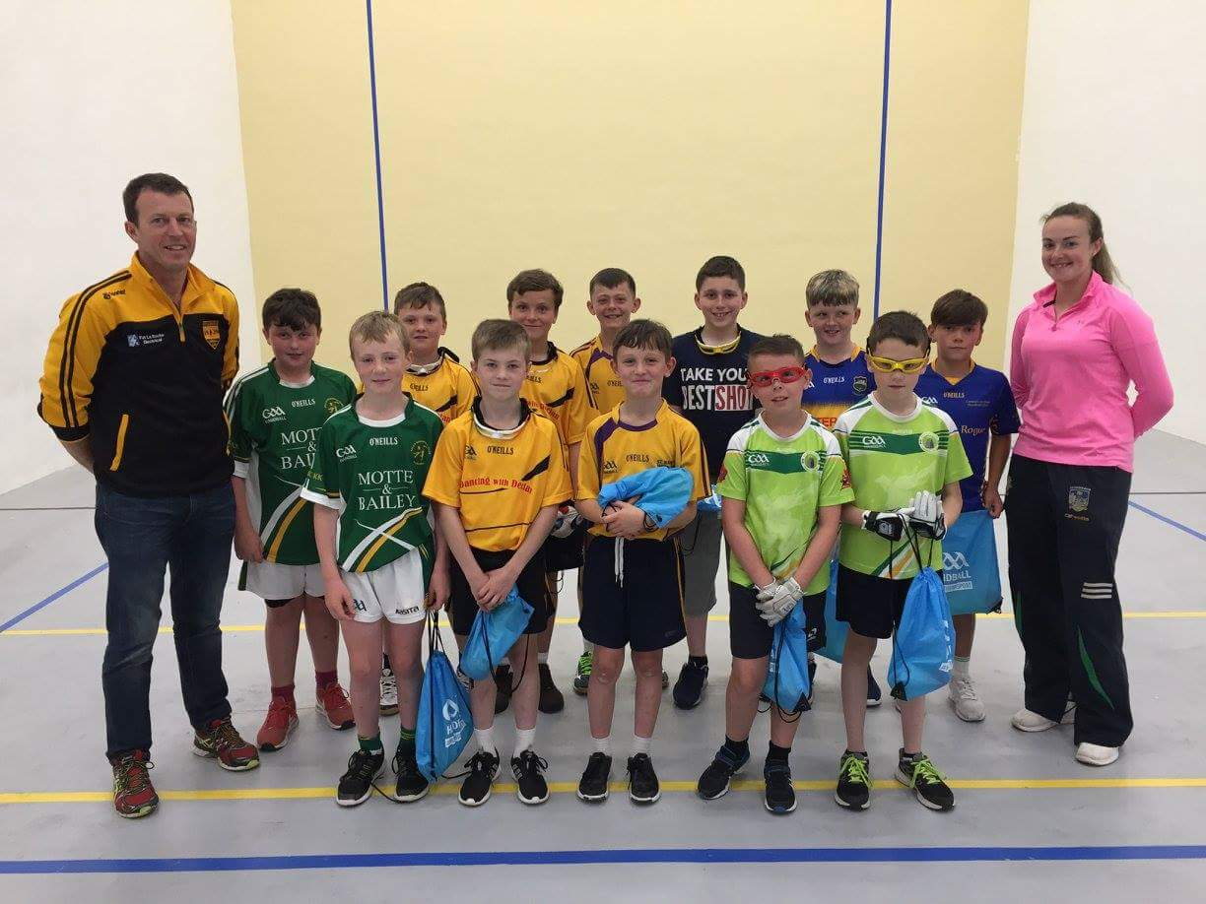
Boys Under 11 with John Roche Castlebridge Official & Senior Ladies Runner Up Martina McMahon

